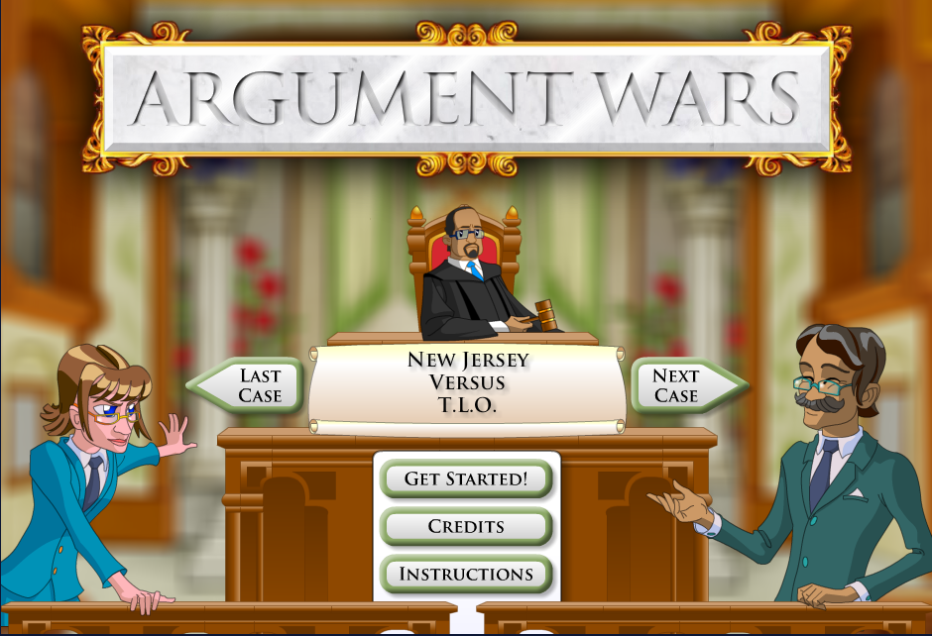
Argument Wars: Impact Guide
For Players

Argument Wars is a game developed in 2010 by Filament Games and iCivics freely available to play on the iCivics website. In Argument Wars, players take on the role of a lawyer fighting to win an argument in a U.S. Supreme Court case. The cases are taken from influential cases in the Supreme Court’s history. Players must utilize skills in persuasion as well as knowledge of constitutional law to convince a judge that the law favors their argument.
How to use this guide: Players – We’ve identified several interesting or important themes in the game. As you play through, reflect on your play. How have you experienced these themes? Are there other important ones present in the game? What kind of impact does your play allow in the larger world? Answer the questions we’ve provided – but feel free to add more at www.gamesandimpact.org.
Warning: Questions contain some spoilers about the games.

Theme: Constitutional Law
At the heart of Argument Wars is the practice of interpreting the Constitution of the United States, and applying that interpretation in defense of an argument. The first task asked of the player when starting a case is to determine which of the constitutional amendments the issue on trial is centered around. Then players use cards representing a series of potential supporting arguments that range from philosophical ideas to prior Supreme Court judgments that set a precedent for the argument being made. Constructing these arguments requires players to interrogate not only the words of the constitutional amendments, but in many cases must ask what the original intent of the amendment was and balance this against the practical facts of the case.

Game
- How did the game mechanic of representing supporting arguments through cards affect the experience of arguing your case?
- The success condition of the game is to be awarded more points for your argument from the judge. How do you think the game designers chose how many points to award particular supports? Do you feel some highly rewarded evidence, or some evidence that was rejected as poor, reveals bias from the design team?
- The game forces the player to choose which constitutional claim they wish to support before being given details or the context behind the case. How does this influence the choice of which side you choose to support?
Player
- Did the game succeed in increasing your understanding of the breadth of Supreme Court cases? What kinds of issues brought up surprised you? Were there any debates you expected to see featured that weren’t?
- Were any of the cases presented ethically challenging? Which choices did you find the toughest to support? Which cases were the easiest?
- As a player, you relinquish control over the final decision of the case to the judge in the game. In criminal courts, a jury made up of randomly selected citizens typically passes judgment, but in constitutional cases, regular citizens do not have an active role in the case. In the Supreme Court, judgment is passed exclusively by the nine Supreme Court justices. How did this game change your view on the role of the Supreme Court justices?

World
- Did the game change the way you think about constitutional law? How does it differ from criminal law?
- Given the arguments you made in the game, how do you think Supreme Court decisions impact the lives of Americans?
- Should Argument Wars be used to teach civic engagement and the role of the judicial branch of government? Why or why not? Would you recommend it to teachers?

Theme: Persuasion
Argument Wars positions the player as a lawyer constructing an argument to present to a Supreme Court justice. Arguments must be constructed using supporting evidence from prior case law and societal standards. Often, constitutional arguments cannot be broken down into a pure comparison of factual data, but must incorporate moral and philosophical arguments about human rights, the role of government, and societal contexts. Players are required to apply critical thinking and persuasive argumentation skills as a means of engaging in the civic context of the subject of constitutional law.

Game
- Do you think the game accurately portrays the decision making process that goes into assembling a constitutional argument before the Supreme Court?
- What challenges in making an argument persuasive were not represented by the game mechanics?
- The game only allows the player to select from three randomly available argument cards at a time. How did this randomness factor change your interaction with the game and the content of the cases?

Player
- Compare the results of your case outcomes with the judgments made in the real cases. If they differ, do you feel the Supreme Court came to the wrong conclusion? If they are the same, do you feel your line of argumentation followed the real claims made in the case?
- What knowledge did you use to determine which arguments would strongly support your case?
- Did you feel the game supported learning how to construct stronger arguments?
- How did your argument evolve as your opponent provided support for his case?
- Did any of the cases challenge your existing assumptions about constitutional issues?

World
- Does the process of constructing an argument for constitutional case law translate to persuasive argumentation in other contexts? Why or why not?
- Do you think studying legal trials is an effective means of teaching persuasive argumentation?
- Why is understanding how constitutional arguments are formulated important for engaged citizenship?

